My walk group details

Names of Walk leader(s):
Name of community:
Name of local walk champion (if known):
Recreation staff, MPAL, or Health Board member

Email: Phone:
Meet up location of walk:
(Describe the location)
Civic Address:
Start Date/Day: Time:
Please email this completed form to walk@hikenovascotia.ca (you can scan and print or just type on the form and resave)

** Once we receive your completed form, we will send you your vest, clipboard, first aid kit, copies of forms. We will also help you promote your group!
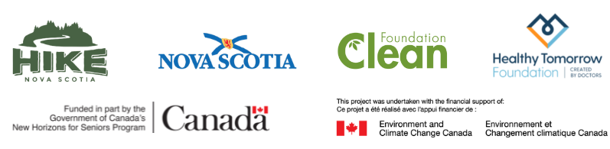
Thank you!!

