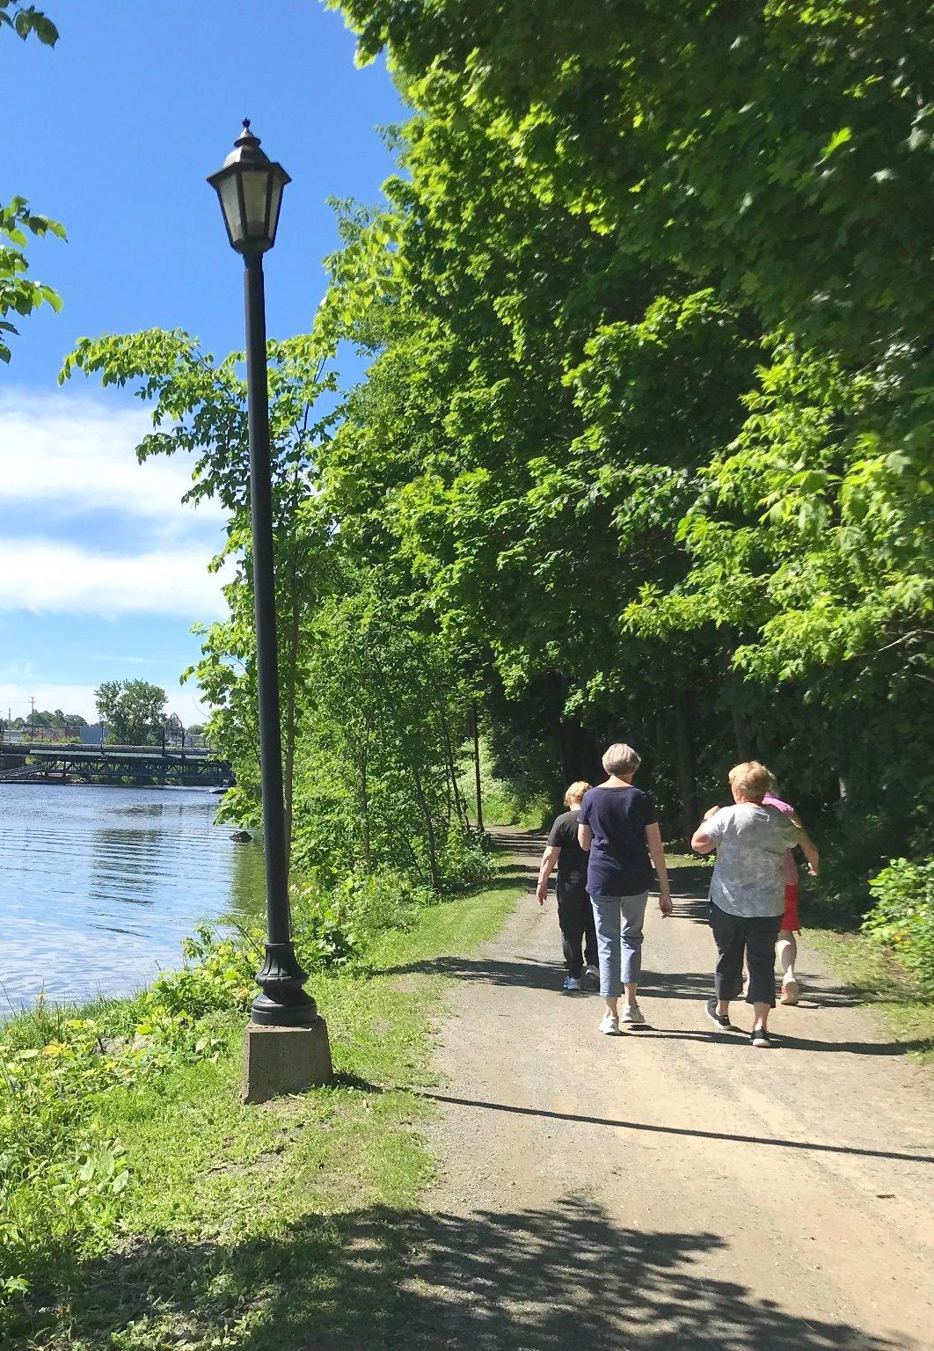
Walk Leader Training Manual

revised December, 2022 PLEASE DO NOT COPY WITHOUT PERMISSION

Table of Contents
Introduction 2
About NS Walks 2
Goal of NS Walks 2
What we do 2
A Hike Nova Scotia Project 2
Our Partners 3
Our Advisory Committee 3
What does health mean to you? 4
Benefits of Physical Activity 4
How much physical activity should we get and how often? 5
Stages of Change: How we think when we start new habits 6
Being a Leader 7
Leadership 7
Qualities of a Walk Leader 8
Managing the pace of the group 8
Defining moderate physical activity 9
Choosing a good walking route for the walk 9
SAMPLE Risk Assessment Form 10
Getting Prepared to Lead Walks 11
Key tasks in leading walks 11
Confidence to Lead Walks 12
Proper Clothing and Equipment 13
NS Walks Walk Leader Insurance 2021 13
Participant and Leader Forms 15
Participant forms 15
Leader Forms/Tools 16
Promoting Your Walk Group 16
Registration process for participants to join your walk group 17
Walk Leader Readiness Checklist 17
What to carry in your backpack 18
References 27

Introduction

Thank you for taking our walk leader training. We hope this training and these resources will provide you with the skills, confidence and knowledge you will need to lead a walking group in your community. There are places for you to make notes in the manual.

About NS Walks

Goal of NS Walks
To create social support that increases opportunities for adults who are currently less active to enjoy the benefits of walking. Walking includes all abilities and mobility methods.

What we do

- Provide walking group leader recruitment, training and ongoing support.
- Work with community organizations to support walking for the target groups.
- Connect Nova Scotians to walking groups in their community.

A Hike Nova Scotia Program

Formed in 2007, Hike NS is a non-profit organization that encourages and promotes a growing hiking culture throughout Nova Scotia. We:
- Strive to be the voice for those who hike, walk and snowshoe. With every step we’re building a community of outdoor adventure enthusiasts. Join us and get out there on the trails.
- Encourage and promote hiking, walking and snowshoeing throughout Nova Scotia.
- Offer a wide variety of events including Fall & Winter Guided Hike Series, annual Hiking Summit, Outdoor Council of Canada courses, Re-Connecting with Nature workshops and webinars on hiking-related topics.
- Are the proud home of the Nova Scotia Chapter of the International Appalachian Trail.
- Offer the Hiker Challenge program and Leave No Trace Education.
- Engage in advocacy and policy development on hiking issues and strive to keep our great wilderness areas protected.

Our Partners
NS Walks is funded by the Nova Scotia Department of Communities Culture and Heritage, The New Horizons Program for Seniors and the Clean Foundation.

Our Advisory Committee
We are grateful to have had the expertise of a wonderful group of people representing organizations and communities across Nova Scotia. We thank each of these individuals for their dedication to the development of NS Walks:
- Kara Gouthro-Murgatroyd, Alzheimer Society of Nova Scotia
- Helen MacDonnell, Community Links
- Seana Jewer and Peter Arnburg, Dartmouth and South East Community Health Boards
- Leslie Huska, Healthy Minds Cooperative
- Carolyn Bollwerk, Municipality of Cumberland
- Bill VanGorder, Nordic Pole Walking Nova Scotia
- Julia Jennings and Stephanie McCarville, Nova Scotia Health, Community Health Teams
- Trecia Schell, Pictou-Antigonish Regional Library
- Linda Scott, our representative from the disability community and Valley Rep.
- Debbie Bauld, Recreation Nova Scotia
- Janet Barlow and Catherine Droesbeck, Hike Nova Scotia

Thank you to our other supporters: Smith and Andersen, Zoomers Physiotherapy and Health Solutions

What does health mean to you?
The word health is very broad and can mean different things to different people. At one time we used to think of being healthy as simply not having a disease or illness. However, we slowly realized that health includes the whole person, body, mind and social/spirit. All of these parts need to be included for someone to be truly healthy. In addition, we can think of health as a resource that helps us lead the best life we can live.

Physical activity can give us more of this resource to live a healthy life. Fortunately, being physically active can have a positive impact on all parts of health. Each of our walk participants have their own ideas about what health means to them. In this way, let’s remember that our health is individual to each of us. As a leader, having ears to hear what is important to participants in terms of their health helps us to understand their needs and reasons for becoming more active.

Feel free to write down your ideas of what is important to you about your health:

Example: It is important for me to have energy to enjoy my spare time.

Physical ___________________________________________________________
Social ___________________________________________________________
Mental ___________________________________________________________
Spiritual ___________________________________________________________

Benefits of Physical Activity
There are so many benefits to being active. Here are some we know from research:
- Reduces the rate of bone loss that goes with osteoporosis.
- Maintains balance, strength, flexibility, coordination.
- Helps reduce the risk of falls. In short, physical activity helps prolong good health and independence.
- Reduces the risk of over 25 chronic conditions including: stroke, colon cancer, osteoporosis, hypertension, breast cancer, type 2 diabetes, and coronary heart disease.
- Allows us to perform daily tasks with greater ease and comfort and with less fatigue.
- Research shows that as much as half of functional decline between the ages of 30 and 70 is due, not to aging, but to inactivity.
- Gives us energy, decreases stress, and makes us stronger.
- Decreases feelings of anxiety and depression.
What are some benefits and barriers to walking for you? ______________________________________________________________________
______________________________________________________________________
______________________________________________________________________
______________________________________________________________________
______________________________________________________________________

How much physical activity should we get and how often?
Canada’s new 24 hour movement guidelines for adults and people over 65 was produced by the Canadian Association of Exercise Physiology (CSEP) along with Participaction, Health Canada and Queen's University.
Here is a brief overview of what the guidelines suggest:
- Do a variety of types and intensities of physical activity, which includes brisk walking, swimming, cycling.
- Accumulate at least 150 minutes per week of moderate to vigorous activity each week.
- Do muscle strengthening activities using major muscle groups at least twice a week.
- Do activities that challenge balance.
- Include several hours of light physical activities, including standing.
- Sit less, move more.
- Every minute counts.
- Build up activity over time

Stages of Change: How we think when we start new habits
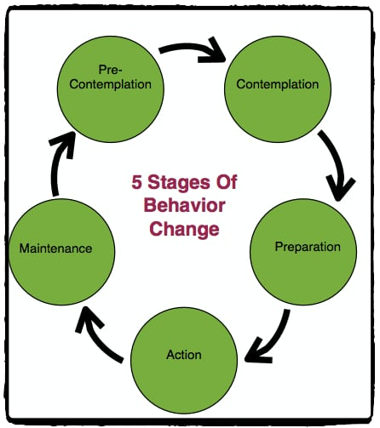
This model was developed in the 1980’s to help understand how we create new habits or get rid of old ones.

The model was first used with smoking. For example, if someone isn’t even thinking about quitting, don’t bother encouraging them to get on the patch. Instead, perhaps help them think about reasons why they may want to quit smoking.

With physical activity, this model can help us as leaders say the right message at the right time to match a participant’s stage of change.
It might mean problem solving with participants to help them think about what they need to do in order to move forward with their new habit. For example, if someone says they don’t know if they have time to walk, ask them about their day and see where they can squeeze it in or ask them about their current priorities.
We want to encourage people who are making the effort to do something healthy for themselves. By the time participants have registered, then shown up to your walk, fortunately, they are in the ACTION stage. They are trying out their new habit.
When participants are in this stage, our words of encouragement and them having a positive, fun time on the walk, will help them to keep coming back to the group. Over time, this will help them get into the “maintenance” stage. In other words, they have created the habit of joining the walk and it will be easier to keep going. It becomes part of one’s life.
Think of a time when you started a new habit. What did it feel like? Write it down.
______________________________________________________________________
______________________________________________________________________
How do you think some of the participants might feel if they haven’t been walking in a while?
______________________________________________________________________
______________________________________________________________________

Being a Leader

Leadership

You don’t need to be timid about calling yourself a “leader”. A leader can simply mean someone who influences another person. You are being a leader by committing to show up and walk with a group of people who want to walk with others.

Instead of telling people how it’s done, we are there to walk with people and to be a role model. We know there are many people who would like to walk more, but want someone to walk with.

You are encouraging and supporting people so they can enjoy the benefits of walking. By creating a safe, fun environment where all participants will feel welcome, you are supporting people to walk more who may not otherwise be out walking.

We are so grateful you are taking on this important role. Indeed, this will be a rewarding experience for both you and the participants.

My notes:
______________________________________________________________________
______________________________________________________________________
______________________________________________________________________

Qualities of a Walk Leader

What words would you use to describe a walk leader? A few words we have heard participants describe walk leaders include being a good listener, supportive, welcoming, observant, confident, warm, etc. Remember, you can develop these qualities, you don’t have to be born with them.

The most important quality which will help you be a good leader is to have a friendly and encouraging attitude so participants will feel welcome and part of the group.

Managing the pace of the group

The pace refers to how fast you are moving. This is a key factor of whether participants will enjoy themselves and decide to come back to the group. Keep in mind, there may be people in your group who haven’t been very active lately. These people are really why we started NS Walks. They may want and need to walk slowly. That’s ok!

The most important thing is that everyone is enjoying themselves. The pace of the group needs to be set by those who walk slower. If some people show up to your group who are faster walkers, that’s ok too!

There are ways to provide variety for faster walkers such as creating another loop in the route or have them walk up ahead and meet you again. Our goal is to create a welcoming, friendly environment for everyone, but especially making sure everyone on the walk is walking at a pace which is comfortable to them. The faster walkers might also be happy to be out for a social stroll to get to know their community members more.

Measuring Effort - The Borg Scale

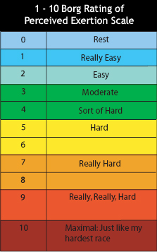

Defining moderate physical activity

As stated in Canada’s physical activity guidelines, we are aiming for people to achieve the recommended amount of physical activity for good health. When you are doing moderate physical activity, you tend to sweat a little and to breathe harder
and your heart beats faster. You should be able to talk, but not sing. Examples of moderate activity include walking quickly, skating and bike riding. Vigorous-intensity physical activities will cause adults to sweat and be ‘out of breath’.

Choosing a good walking route for the walk

- Accessible: Paths easy for all
- Convenient: local to walkers
- Attractive: nice things to look at
- Connected: near local buildings
Other things to consider when choosing a route
- Is there a washroom nearby?
- Are there benches?
- Is the route flat and safe?
- Are there any hazards to keep in mind
- Is the route maintained in Winter?

Think of possible routes in your community that are accessible, convenient and scenic:

- ________________________________________________________________
- ________________________________________________________________
- ________________________________________________________________
- ________________________________________________________________
- ________________________________________________________________

Please complete the Risk Assessment form as you plan where you will walk to identify any hazards you and participants should be aware of before heading out on the walk.

Having a hazard on the route may or may not mean the route won’t work, but it is necessary to make sure the risk from the hazard is minimized. In some cases, a hazard is a temporary problem that might only need a change of walk plans for a period of time.

SAMPLE Risk Assessment Form

Route: ____________________________ Date: __________
Assessment Carried out by: ____________________________
Hazard | Who might be harmed | How is the Risk controlled | Options
Crossing roads | anyone | Inform walkers that it is their responsibility to crossroads safety and at pedestrian crossings where possible | Reinforce message as required
Severe weather | anyone | Identify sheltered places along the route where walkers can wait for severe weather to pass. Ensure walkers are wearing appropriate clothing. | Alternative route or activity (indoor?)
Wildlife | anyone | Stay together as a group, do not approach wildlife, do not leave food, other | Alternative route or activity?

When you have planned where you will walk and when you will start, please complete the My walk group details form and the Volunteer Walk Leader agreement and submit them to Hike NS. We will then send you the rest of the materials you will need including clipboard, reflective vest, first aid kit, copies of forms and some arm bands.

Hike NS Contact: Catherine Droesbeck 902-483-2813 or walk@hikenovascotia.ca

Getting Prepared to Lead Walks

Key tasks in leading walks

Here is an overview of the tasks required of you as a leader/co-leader:

Before the walk:

- Plan your route. Make sure the route is safe, using the Risk assessment form. Walk the route and make note of any hazards people need to be aware of. NOTE: we recommend a 30-45 minute walk to start. If everyone is in agreement, then you can go longer if you wish.

- Contact your participants to introduce yourself, provide details on your walk and ensure they have the forms they need to review/complete (Get Active Questionnaire and Participant agreement and waiver.
The only form they need to complete via hard copy is the waiver form.
If they can’t download or print the form themselves, invite them to visit their local library or recreation centre and they will be happy to print the form for them.

Provide them with walk details, encourage them to bring along water and to wear good walking shoes. Remind them to please leave their dogs at home (unless they are service dogs).

Right before the walk:

- Make sure you have copies of the forms you will need:
- Risk assessment form
- Walk attendance form
- Leader and participant agreement form
- Incident report form

- Pack your kit: vest, clip board, first aid kit, arm bands, pen

As participants arrive:

- Welcome all participants as they arrive, especially new participants.
Collect Participant waiver forms from participants and put them in an envelope. Remember, participants only need to complete these forms once.

- Once everyone has arrived, review the Leader and participant agreement form and Risk Assessment form.

- Take attendance using the Walk attendance form (write the date at the top). Write the names of all new participants on form and you can just checkmark next to any returning participants.

- Review the route with the group, tell participants where you will be walking, approximately how long it might take, and whether there are washroom facilities and benches.

During the walk:

- Encourage participants, be aware of the pace, check in with participants as to how they are feeling, and watch for cues that they are comfortable and enjoying the walk.

- Feel free to share your knowledge about something interesting about the route or ask others if they are aware of the story of the route. If you have faster walkers in the group, invite them to go up ahead, do an extra loop (depending on the route), but stay with each other.

After the walk:

- Make sure all participants have returned from the walk. Congratulate participants for completing the walk. Let participants know when the next walk is scheduled and encourage participants to come to the next walk.

- If possible, this is a great opportunity to have a little social time.

- Invite anyone who might be interested in becoming a walk leader to contact Hike NS. Check in with Hike NS to pass in new participant forms (you can do this after a few weeks).

- Discuss the easiest way to contact group members in case the walk needs to be cancelled (Email, What’s App, Facebook, phone chain)

Confidence to Lead Walks
It is very normal to be a little nervous before leading your first walk. There are a few things to remember to do to ensure a safe and enjoyable walk for all. As time goes by, however, you will naturally become more confident. Hike NS can help answer any questions about things you might be unsure of.
What are some ways you can increase your confidence to lead walks? Write them down:
______________________________________________________________________
______________________________________________________________________

Proper Clothing and Equipment
One of the many great things about walking is that it doesn’t take a lot of special, fancy clothing or equipment. As a walk leader and a role model, we recommend a good pair of sneakers with shock absorption and comfortable, loose fitting clothing. It’s often good to have a light jacket with you as well (or a heavier one or layers if it is cold).

Since we want to be welcoming to those who might be currently less active, it’s important for people to know they do not need fancy work out gear. In fact, it may be off putting to some participants if leaders are dressed in the latest outdoor gear and boots.

In terms of proper clothing for participants, the same thing applies. Recommend sneakers or supportive covered toe walking shoes at least, comfortable clothing, layers if possible, and in warmer months, a cap or hat to keep the sun off one’s face, as well as sunscreen and bug spray.

First-aid course: It is not necessary for you to have completed a first aid course in order to be a walk leader, but if you have done one, that is great! If you are interested in taking one at some point, contact Hike NS and we may be able to arrange a course in your community. In the meantime, you might ask your participants if someone has the course, as many people have taken it.

NS Walks Walk Leader Insurance 2021
Hike Nova Scotia started NS Walks to enhance social support, so more people can enjoy the benefits of walking. We achieve this through a system of walk leader training and ongoing support and promotion to potential participants to encourage walking in communities throughout the province.

As you know, walking is generally a low-risk activity, particularly the walks we are suggesting through NS Walks (planned, local, accessible). That said, Hike Nova Scotia has arranged insurance coverage for our walk group leaders as volunteers of Hike NS.

In order for NS Walks walking group leaders and participants to be covered by this insurance, leaders and participants must comply with the following requirements.

Leaders must:
- Complete the Walk Leader Training (3 hour virtual session)
- Agree to the statements in the Volunteer Walk Leader Agreement
- Carry out the tasks laid out in the agreement and in the Walk Leader Training
- Follow Hike NS’s Harassment Policy

Participants must:
- Complete the Get Active Questionnaire
- Register for a walking group
- Agree and sign the Participant Agreement and Waiver

Leaders and participants please note:
- The activities covered by this insurance only include walking, snowshoeing or hiking events (it does not include other activities such as cycling, water-based activities or other physical activities, nor does it include get-togethers or social events that take place after a walk)
- A walk is only considered to be an NS Walks event where it is led by a trained Walk Leader who follows the protocol laid out in the Walk Leader Agreement
- Walks will take place in towns, villages and cities and in rural, urban and suburban settings, and may be routed along neighbourhood streets, in local parks and on trails
- Walks must take place on public property such as publicly accessible municipal, provincial and federal land and publicly accessible trails
- Walks are not to take place on private property without landowner permission
- Walks are outside (although groups may use indoor walking tracks or walk in malls or similar facilities if the weather is inclement)
- A meeting spot will be established and participants will meet the walk leader there
- Walks are meant for adults. Those who are 16 and under must be accompanied by their caregiver at all times.
- If a walking group is formed specifically for those aged 16 and under where caregivers are not in attendance, walk leaders must have a criminal record check and vulnerable sector check completed before leading a walk
- Transportation in private vehicles is not to be provided for or by Leaders or participants to any other leaders or participants (if this does occur, it is not covered by this insurance)
- When using the NS Walks Walk Leader Facebook Group, respectful behaviour is expected. This also applies to a specific walking group’s online groups such as Facebook or other applications used to stay in touch. See Writing Great Rules for Your Facebook Group | Facebook Community

Once you submit your My Walk Group Details to Hike NS, we will ask you to review and submit the Volunteer Walk Leader Agreement. The agreement will outline your responsibilities as a volunteer in order to help ensure a safe and enjoyable walk for all, including you as a leader.

We have put these steps in place to minimize risk and to put reasonable onus on participants for their own safety. The next section describes each step and why we use them.

Participant and Leader Forms
NS Walks is a new initiative and we have set up steps so we are able to evaluate the program and make changes when necessary. We also want to ensure good communication between leaders and participants in terms of safety and expectations, which is why we have forms for participants and leaders to complete. All forms are available for download at NSWalks.ca

Participant forms
- The Get Active Questionnaire and reference sheet was developed by Canadian health and fitness professionals. We suggest participants do this quick health self evaluation in case there are any issues that need to be checked out before they join a walking group. They can review this form online and only if they answer “yes” to any of the questions, they should have a chat with their health care provider before joining the walk (You do not need to see or collect this form. Participants can keep the form.)
- The Participant Agreement and Waiver explains that participants joining the walk will be responsible for their own safety. Participants are asked to review and sign this form before they join the group for the first time. This form only needs to be completed ONCE. Please collect these forms and return to Hike NS.

Leader Forms/Tools
- Risk Assessment form - please use this as you are planning your walk, but also review it with participants if there are any hazards they should be aware of on the walk.

- My Walk Group Details - This form tells us the location and schedule of your group walks. Please complete this form and email it back to us at Hike NS and we will send you your materials.

- Walk Attendance form - please take attendance at each walk to track numbers of participants and to encourage participants. Once you have filled the form, you can send it back to Hike NS.

- Leader and Participant Agreement - This form states what the walk leader will be responsible for in terms of safety. As mentioned, you will have to plan out the route to minimize any hazard and will do your best to keep participants safe during the walk. The participant agreement states what participants will be responsible for in terms of their own safety and cooperation as a group member.
Please take a few minutes before each walk to review this with participants, it has good safety tips and helps reassure participants.
- Incident Report form - In the rare chance that an incident or injury occurs during your walk, please complete this form and submit to Hike NS at your earliest convenience.

Promoting Your Walk Group

As a Walk Leader, you will have lots of help promoting your walk group. We are fortunate to have lots of partners around Nova Scotia who are excited to get the word out about group walks! Some of these partners include the Healthy Tomorrow Foundation through their Make your Move campaign, NSconnect.ca, 211, your local municipality, Hike NS website, our advisory committee and other partners.

That said, there is nothing better than local promotion and word of mouth to help spread the word. Are there local contacts in your community who work with people who may be less active and interested in joining your walk? Once you pick your walk day and time, share this information with them.
We will create a flyer you or a community organization can use to promote your walk. You will receive the flyer after you send us details of your walk. A sample flyer is on page 26.

Registration process for participants to join your walk group
Currently, registration for walk groups starts at www.nswalks.ca. Interested participants sign up to indicate they want to join a walk group in their community. Once we have a leader in place for their community, we send leaders the contact information for those participants who can then reach out to them. Participants can also access the forms they need to get started. If they cannot download the forms themselves, their local library or recreation department can help.
In the near future, we will have the ability to directly link interested participants to walk groups in their community using NSconnect.ca. Stay tuned for more information on this.

Walk Leader Readiness Checklist

___ Participate in walk leader training
___ Connect with Catherine to see if there is already a group or leader in your area that you can work with
___ Decide on your route and schedule (if you have a local walk champion such as a Municipal physical activity coordinator, you can discuss this with them)

___ Email Hike NS to confirm walk time, day and location (Complete the My Group
Walk Details form)

___ Complete your Volunteer Walk Leader Agreement and submit to Hike NS
___ Receive your clipboard, safety sash and other materials from Hike NS
___ Have copies of leader and participants forms ready to use in an envelope
___ Start your walks!!

What to carry in your backpack

We recommend your backpack include the following items:

- A fully charged cell phone.
- Clipboard for paperwork (provided)
- Copies of forms
  - Get Active Questionnaire, Participant agreement and waiver (in case someone shows up without having registered)
  - Leader and Participant agreement form (back to back forms)
  - Completed Risk assessment form
  - Walk attendance form
  - Incident report form
- A few pens
- Small first-aid kit. (provided)
- Hat, gloves (seasonal)
- Arm bands
- Hand sanitizer
- Water bottle

Thank you for your commitment to increasing walking in your community and happy walking!

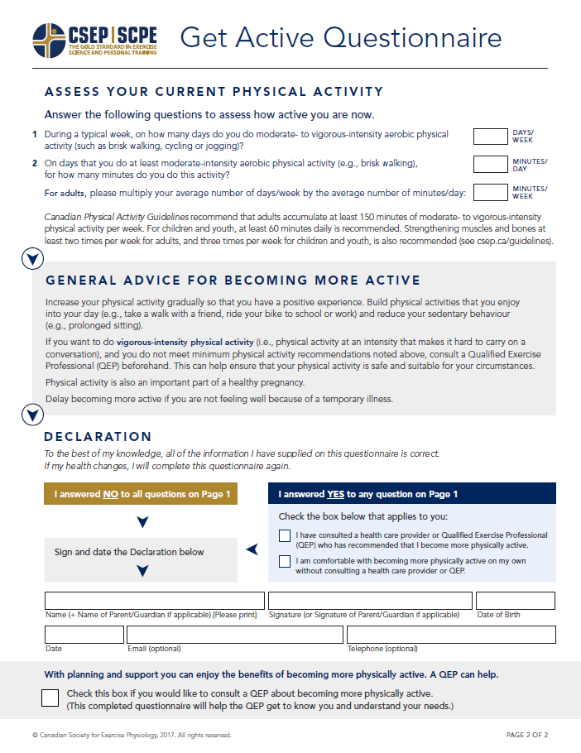
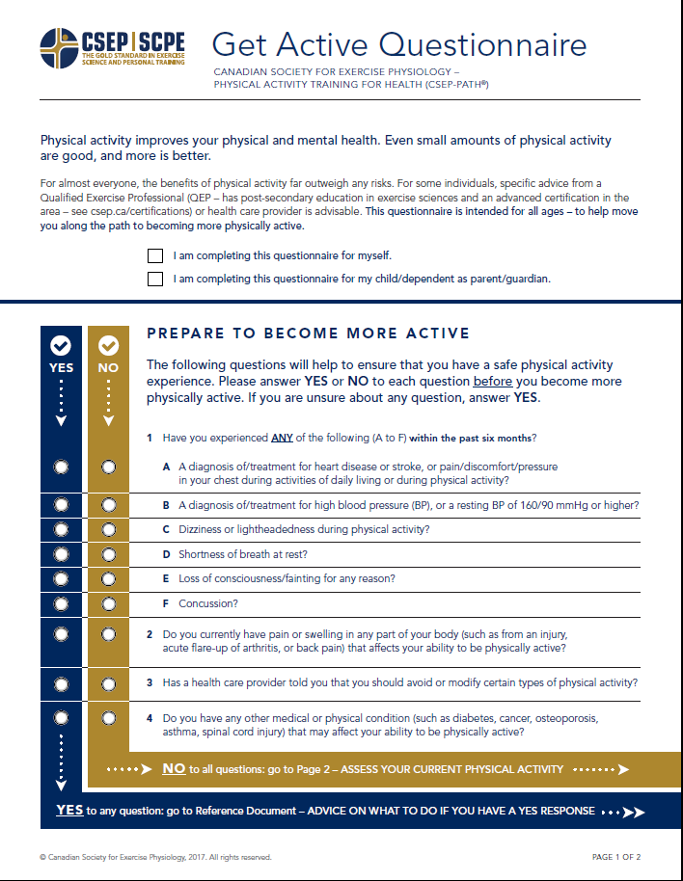
Get Active Questionnaire
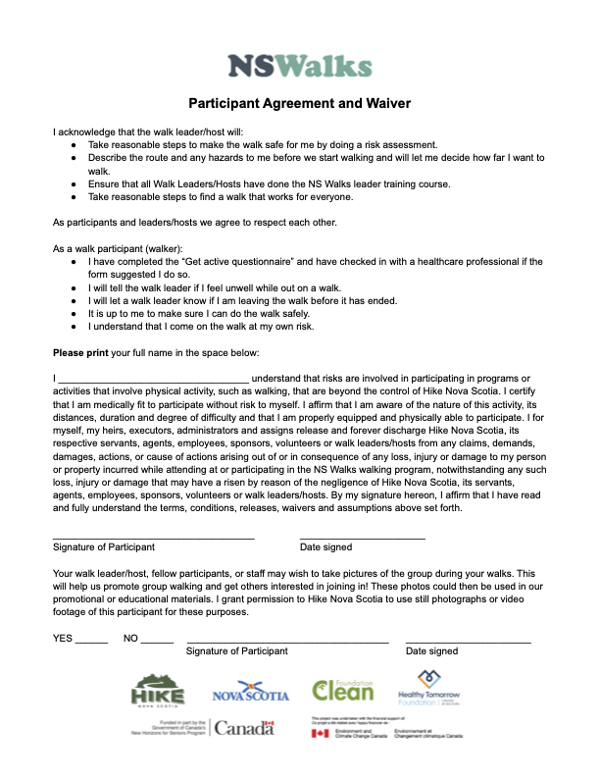
Participant Agreement and Waiver
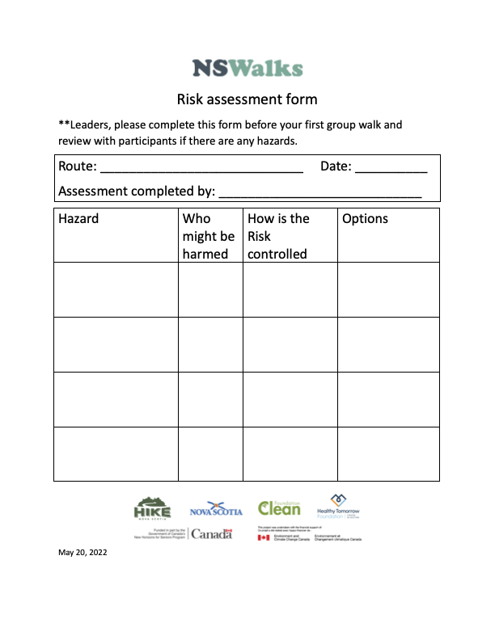
Risk Assessment Form
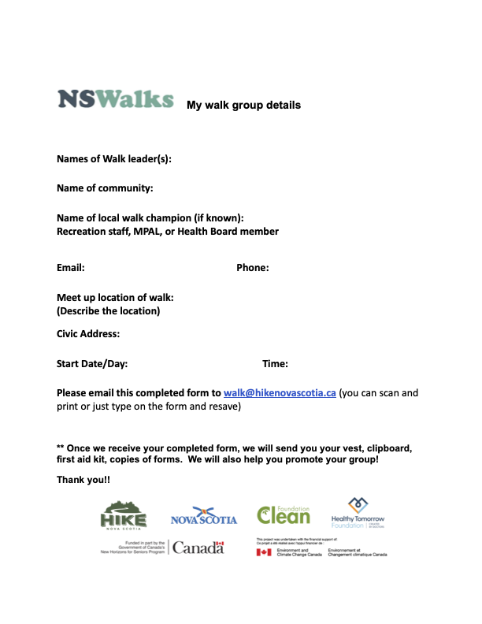
My Walk Group Details
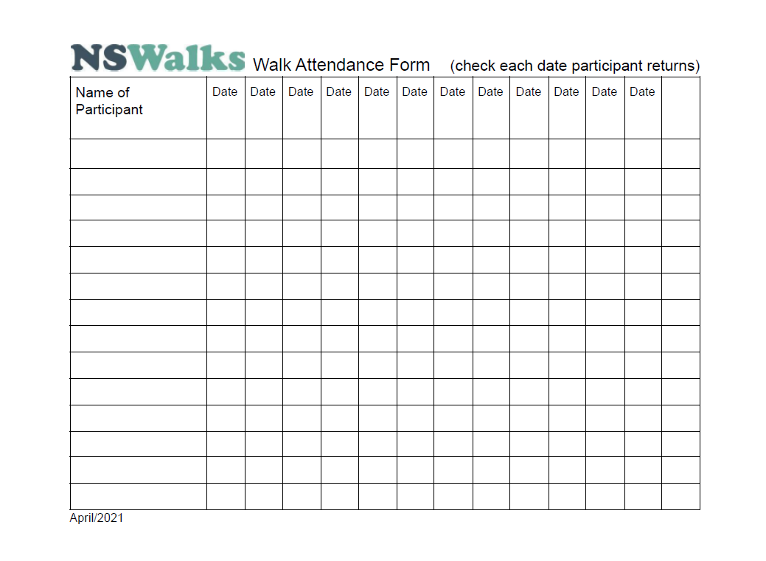
Walk Attendance Form
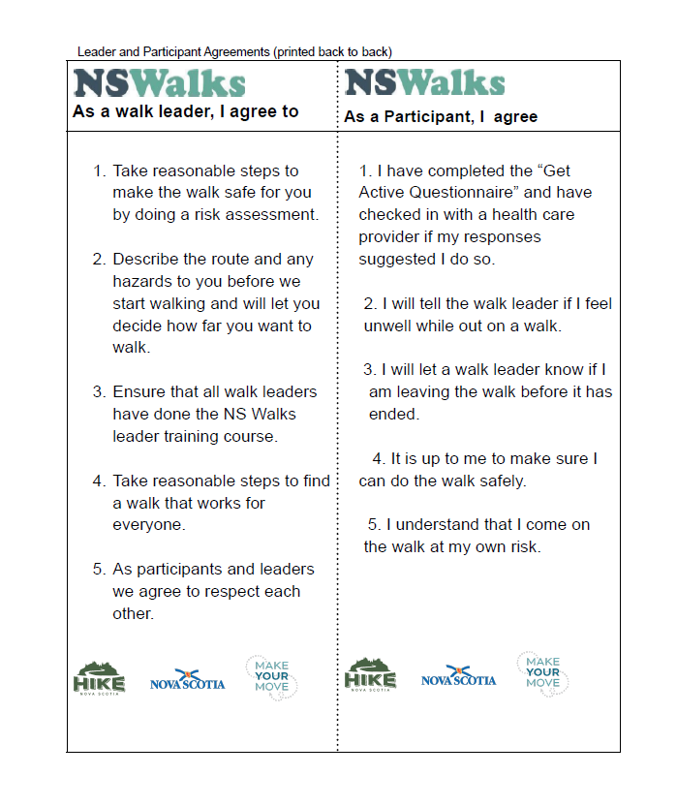
Leader and Participant Agreement
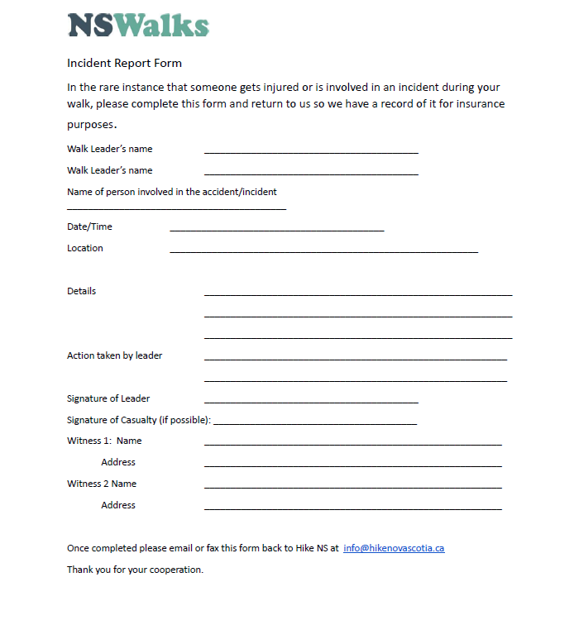
Incident Report

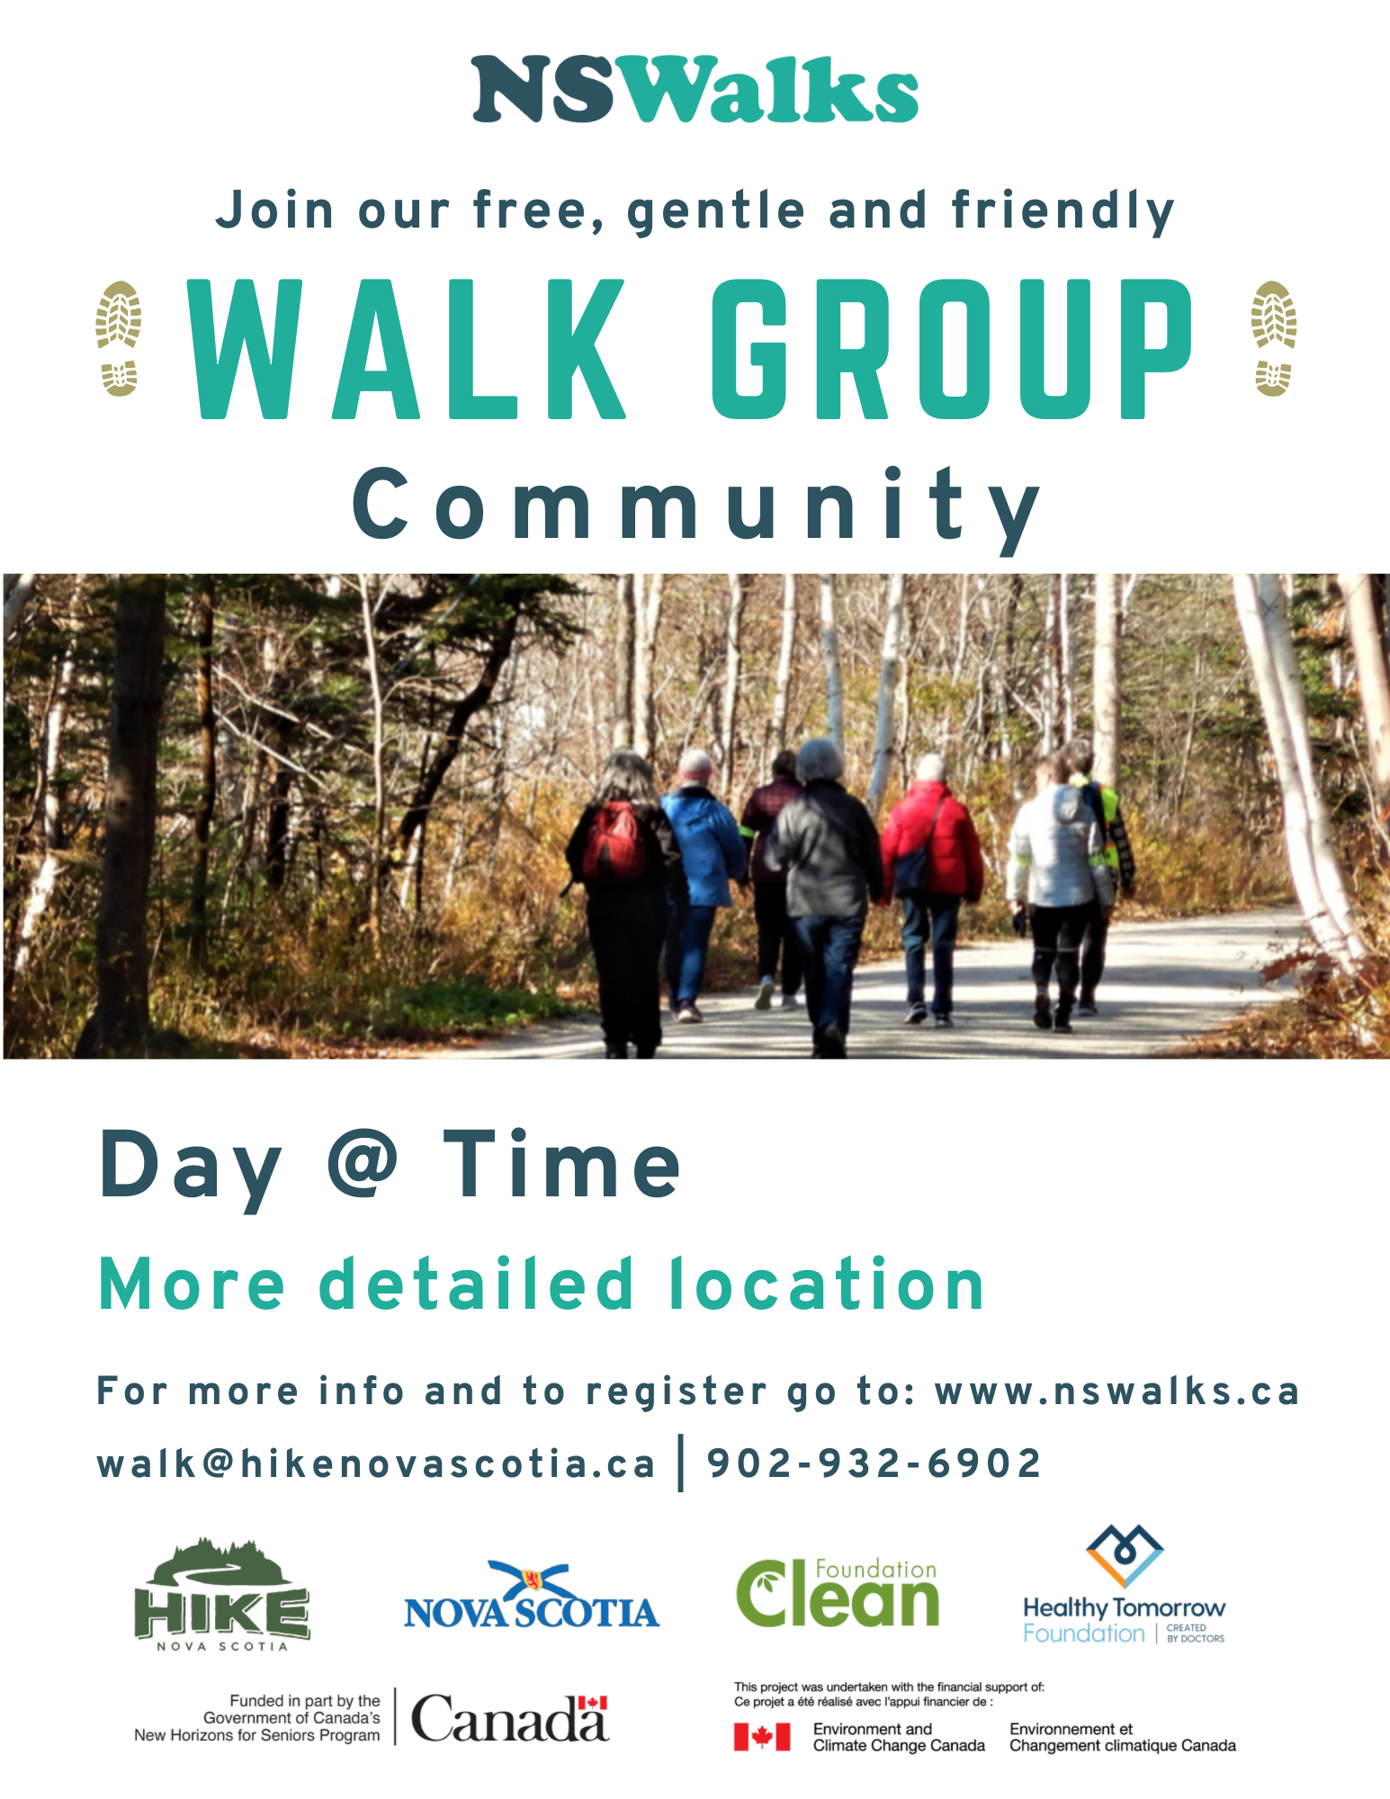
NS Walks Flyer

References

Borg, G. A. (1982). Psychophysical bases of perceived exertion. Medicine & science in
sports & exercise.

CSEP. Canadian 24-Hour Movement Guidelines for Adults ages 65 years and older.
Retrieved from https://csepguidelines.ca/adults-65/

Diclemente, C. C., & Prochaska, J. O. (1998). Toward a Comprehensive,
Transtheoretical Model of Change. Treating Addictive Behaviors, 3-24.
doi:10.1007/978-1-4899-1934-2_1

Heart and Stroke Foundation. (2011, April 7). Heart&Stroke Walkabout™ Announces
the First Walkabout Walkability Award Recipients [Press release]. Retrieved from
https://developns.ca/wp-content/uploads/2019/07/HeartStroke.pdf

Paths for All. (n.d.). Training for Health Walk projects in the community. Retrieved from
https://www.pathsforall.org.uk/training-for-health-walk-projects-in-the-community

